CAVE SCIENCE Vol 18, No. 3, December 1991
Transactions of the British Cave Research Association

A New Survey of Råggejavri-Raigi and the Hellemofjord Karst, Norway
Stein-Erik LAURITZEN, Jiri KYSELAK and Reider LØVLIE

Abstract: In order to accommodate the needs for a sampling programme. Råggejavri-Raigi (RJR), the deepest cave in Scandinavia, was resurveyed. We claim the present survey to satisfy BCRA standard 5C. The cave has a surveyed length of 1915 m, with an estimated total length exceeding 2000 m. The surveyed depth is 580 m with a through trip elevation of 579 m. The fiord entrance is situated at 80 m a.s.l. Several interesting leads still remain in the cave, and we hope future visitors may explore and survey them. The cave survey is stored on magnetic media for easy update. On the northern Noroldahkvarri plateau, several extensions in Østhullet were found, giving the cave a total length of 900 m. Several small caves and choked shafts were found, but none of them yielded cavities of any significant size, in spite of digging attempts. All Noroldahkvarri caves were still in their untouched, pristine state, whilst RJR shows signs of travel due to the intense attention the system has received during the past 20 years since its discovery. Finally, we suggest a standard nomenclature for RJR.

Råggejavri-Raigi (RJR), situated in the southern wall of Hellemofjord, North Norway, is the deepest cave in Scandinavia. The cave potential was first alluded to by Foslie (1942) who, during geological mapping, pointed to streams sinking into steeply dipping marble bands on top of the plateaus around Hellemofjord. Foslie associated them to the powerful submarine springs which occur at both sides of the fiord and suggested that immense caves must exist inside the fiord walls. He was indeed right, but it would take some 27 years to confirm his assertions. Foslie's ideas were later cited by Corbel (1957), but no penetrative exploration was done until British cavers, led by David Heap (1969, 1970) explored and surveyed the system. Being among the 30 deepest caves in the world at that time (Courbon 1972), and still providing No 7 of the deepest through-trips available (Courbon and Chabert 1986), the cave is a celebrated one and has experienced much attention ever since. Almost every year, caving groups from all over Europe have visited the cave. We gather that several hundred individual through-trips must have been made during the 20 years since its discovery.
In 1990, the Hellemofjord caves became subject to a closer morphological and stratigraphic study in order to obtain paleoclimatic and geomorphic information. The project belongs to the general "Global Change" Program, where the purpose is to provide a database for past climatic changes.
The original Kendal Caving Club (KCC) survey (Heap 1971) has proven remarkably accurate, in spite of the logistically difficult conditions prevailing at the time when it was made. However, 20 years' of visits has naturally revealed new details and routes. In particular, the connection to the fiord cave (Vouleb Råggejavre-Raige), and a much used high level route above Store Skrå (The Big Rift) necessitated accurate documentation. It was felt that the old survey did not allow us to locate our observations and sediment sections with sufficient accuracy, so we would in any case have to connect these locations to a new survey traverse. We therefore found it most convenient to re-survey the whole cave, thus providing new fixed stations for future extensions.
The purpose of this paper is to present our revised surveys and report some new findings on the northern, Noroldahkvarri plateau.

GEOLOGICAL AND GEOMORPHOLOGICAL
SETTING

Hellemofjord forms the southern branch of the Tysfjord fiordvalley complex in Nordland, Norway, Figure 1. These fjords are incised into an extensive massif of crystalline basement windows surrounded by metasediments. The resistant massifs form extensive paleic plateaus, one of them is the "Gipfelrand" at about 1000+ m a.s.l., yet another plateau is found at around 700 m a.s.l. For closer explanation of the "paleic" or "old", preglacial surface of Norway, see Gjessing (1967) and references therein. Hellemofjord cuts deeply into the 700 m plateau. Including the depth of the fiord (-455 m), the total relief adds up to some 1200 m. The fiord cuts through a synclinal structure which outcrops as nearly vertical strata of mica schist, gneiss and marbles, forming the typically "Norwegian" stripe karst setting (Horn 1937), (Figure 2).
The combination of vertically continuous carbonate bands (from the lakes on the plateau to down below sea level) and large scale fracturing along vertical (EW) and subhorizontal sets, provide optimal conditions for deep karstification. Although this situation is preferential for creating underground drainage, it does not necessarily support explorable caves. Vertical drops depend on the location of corresponding vertical fractures. If the density of such vertical fractures is low, the passages may locally become forced along the other, subhorizontal fracture set, forming shallow, perched sumps. This effect was noted by Heap (1969) on the Noroldahk plateau (i.e. the Noroldahk-Raigi cave), and it is also evident in the upstream section of Råggejavri-Raigi. For instance, if an upper entrance did not happen to exist by chance in a distal position of the present stream, RJR would never have been found unless the upstream sumps could have been dived.
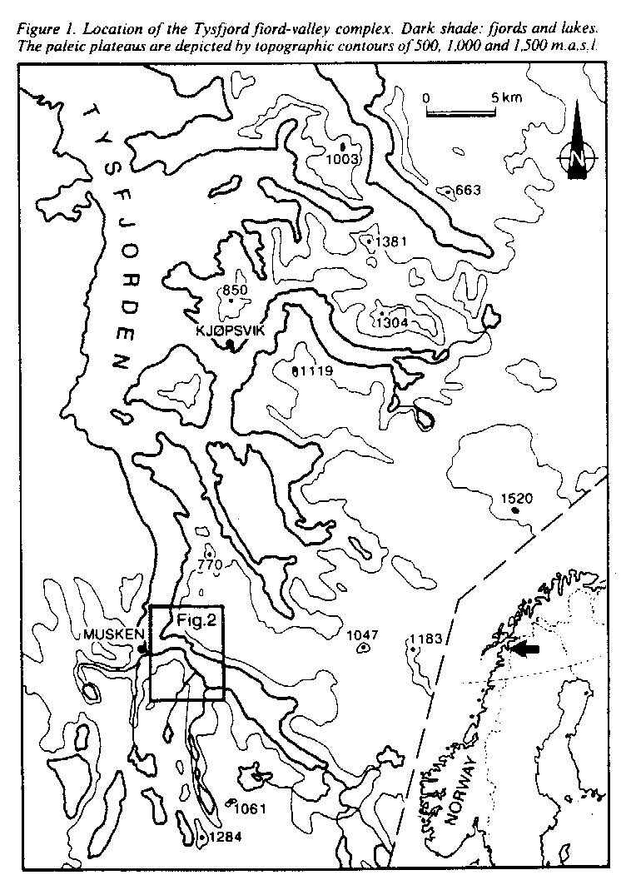
The RJR marble band is of variable stratigraphic thickness, 20-30 m at most. This can be seen in some of the largest chambers, where the wallrock is exposed. The RJR marble is the westernmost of at least three prominent, parallel bands. The thickest, middle band has not yet yielded caves, but the eastern band contains an underground system (Nieidavaggi sink cave, Beck 1971). The three bands can be seen to continue on the north side of the fiord. They are paralleled by similar cave distributions. The supposed RJR continuation may be the marble band that hosts Lauknesfjellgrotta (Beck 1971) and the Raigejokka resurgence cave (Heap 1970). The middle marble band (Lauknesfjell marble) is the most prominent and is visible at a long distance. It outcrops with a thickness up to about 100 m. This marble supports a large doline (about 100 m diameter, the largest in the area) with an underfit streamsink, several grikes and small choked shafts, but no substantial caves (except for JRP-cave, see below). The large doline and Lauknesfjellgrotta sinks are controlled by the same EW fracture lineament. The easternmost marble band hosts several prominent caves (Heap 1969, Beck 1971).
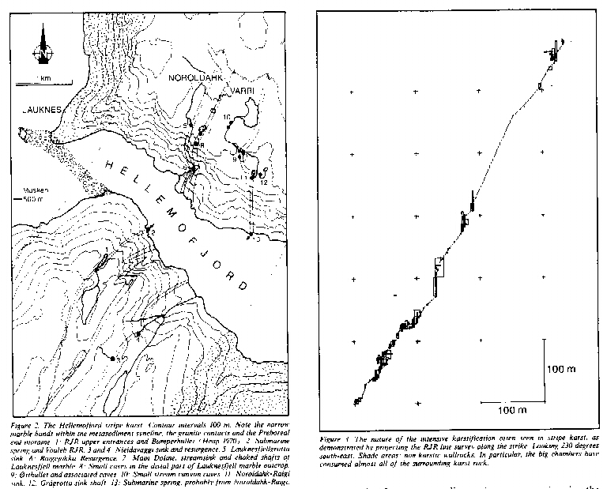
In all, except for a few other marble bands of negligible size, the Hellemofjord karst is controlled by three major, steeply dipping carbonate horizons. The central, apparently thickest outcrop do not seem to yield significant caves, whilst the two marginal bands support cave systems which are immense when compared to the size of the host outcrops. This effect is demonstrated in Figure 3, where RJR is projected along the strike of the marble band.
Only a few hundred meters west of the cave area, the metasediments are replaced by resistant basement rocks (the Tysfjord granites of Foslie 1942). The almost vertical contact has apparently made a significant barrier to glacial erosion, as the fiord displays a major constriction at this site, (Figure 2). Such topographic constrictions commonly affect glacier movements within fiords, particularly under deglaciations, when the ice mass dynamically unstable. A major end moraine was deposited in Constriction between Lauknes and Segelnes (Figure 2), which been ascribed to the Preboreal (D-event, 9,400 -9,700 B.P., Andersen 1975, Andersen et al 1981). The constriction would have provided a kind of "baselevel" for ice movements, as the compressed fiord glacier might have supported an englacial
Watertable which in turn would control the phreatic zone within the karstic siderocks. This would be the case for several of the past glacial cycles. In even more distant times, we may imagine the granite contact to form a much more stable baselevel for the incipient fjord. Within the possibilities dictated by the fracture density, either or both of these two types of baselevel may be responsible for the paleo-resurgence levels and rejuvenation features that we find inside the caves. The detailed timing of these stages would be subject to discussions of valley entrenchment and conduit wall retreat rates as outlined elsewhere (Lauritzen 1990).

THE CAVE SURVEY

Adaptions from the KCC map

The streamwav in the bottom of Store Skrå was not resurveyed, as our route came in through the high level traverse down a short shaft (Main Slide) directly above Ulvegangen (Wolf Walk). We have therefore adapted survey details of Store Skrå from the original KCC map, which we consider as quite accurate.
Storstupet was not resurveyed thoroughly. The distance from our rope belay (above the winch balcony) to the bottom of the pitch was measured with a topofil device as 152 m. Average azimuth and inclination were estimated from the KCC survey. We admit that this is a rather unsatisfactory approach, as we do not know the basis of the KCC map at this place. Storstupet is a very misty and inconvenient place to survey, and we gather that the original surveyors also encountered visibility problems here (Heap 1971). The conditions may be more favorable during winter when the thermal winds become reversed, and when we should expect the discharge and spray from the waterfall to be at a minimum.

Survey standard

Nylon-coated steel tapes were used with the traditional Sunto compass and clinometer. Distance was read to the nearest centimeter and angles to the nearest degree. Survey stations were placed on protruding features of solid rock or large boulders. Occasionally, and always at the beginning of promising leads, the survey stations were either marked with cairns (wet places), or marked with carbide soot (encircled spot with station number). Neither of these marks are very durable; our experience is that modest soot marks may last up to some 5 years if the place is reasonably dry. However, we hope that we, by our approach, may have attained a compromise between upsetting other visitors and providing confident links for extensions during the next few Years.
The surveys (Figures 4 and 5) should reach the standard of BCRA grade 5C (Ellis 1976). There are only a few closed loops to test the internal accuracy of the survey measurements. Standard deviations of azimuth and inclination readings were less than one' degree in these loops. The new 1:50.000 scale topographic maps (M 711 series, Sheet 2230 IV. Hellemobotn) would place the cave entrance at approximately 580 m a.s.l. Adapting this map as the "ground truth", it compares quite favorably with the surveyed depth to sea level (582 m), suggesting a maximum misfit of less than a few per cent. Please note that one link, Storstupet, is not yet satisfactorily surveyed, see discussion above. The "C" standard was satisfied because cross-sections were recorded at every survey station, supported by measurements of the distances to floor, ceiling, right and left wall. This procedure is not much more time-consuming than estimating the same distances, but it greatly extends the usefulness of the survey.
A total of 172 survey legs were made. The distribution of survey leg lengths is shown in Figure 6, the modal leg length is 4 - 7 m. This is quite common for cave surveys of this type and ensure that reasonable detail is maintained in the line survey. The total surveyed length is 1915 m. The total surveyed depth is 580 m. We estimate that the remaining known but unsurveyed passages would easily add up to more than 100 m, taking the cave into the 2 km class. The through-trip elevation difference is 579 m, although the depth is apt to change with by a few per cent when better survey legs for Storstupet become available.

Aneroid altimeter measurements

In order to support the surveyed levels with independent measurements, relative elevations were estimated using an aneroid Paulin Altimeter with -350 - +720 m nominal range, readable to 0.5 m. The reliability of a pressure device underground may be subject to debate, but we have nevertheless performed a few readings that may be compared to the surveyed depths. However, surface checks have proven quite useful when repeated readings are made at short intervals under stable weather conditions. The results are shown in Table 1.
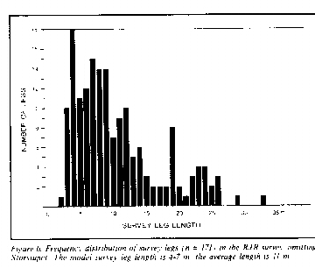
Altimeter and survey readings compare quite favourably when both readings are taken either on the surface or underground. However, in the case of the elevation between Upper Entrance and the Winch Balcony, the difference is some 10 % which we may ascribe to a pressure anomaly between the cave and the surface. This is clearly demonstrated by the strong thermal wind that was drawn into the upper entrance. Based on the measurements in Table 1, we feel quite confident that the Fjord Entrance is situated 80 m a.s.1 rather than 100 m as suggested by the original survey.

Location | Altimeter | Survey
Upper Entrance-Winch Balcony | 94 m | 105 m
Storstupet. Rope belay-bottom | 145 m | 142 m
Sealevel - Fiord Entrance | 77 m | 80 m

Table 1 Comparison of relative aneroid altimeter readings and survey

Promising leads in the cave

Several bits and pieces were for various reasons not included in the survey:
1) The streamway part of Store Skrå may benefit from a new survey performed either during drought summer or winter conditions. Upstream pushes of the streamway may also become feasible in winter.
2) A promising lead (The French Opening) goes north-east from the top of Main Slide, the first rope pitch in the high-level route above Ulvegangen. These passages may lead across the top of Storstupet, and most probably extend the pitch upwards with several tens of meters. We gather that this route has been used by French groups in the past.
3) The main stream at the base of Storstupet disappears into a tight shaft which is passable at low water stages, preferably in winter.
4) The series of large avens distally of Storstupet have evidently acted as earlier knickpoints in the stream recession. They may connect to the nearby Bumperhullet drainage system (Heap 1970). Several attempts have been made to climb these avens; for instance, we know of attempts by the Norwegian Bodø group that have penetrated some 30 m up into the avens.
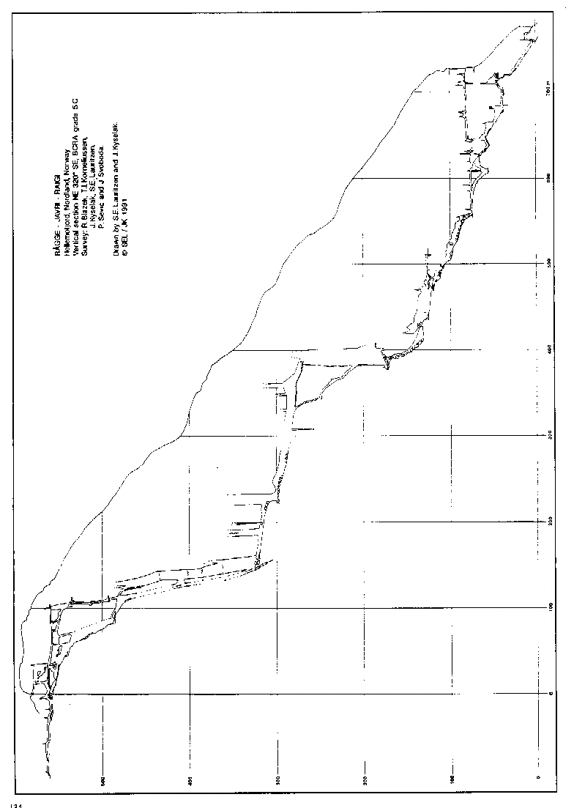
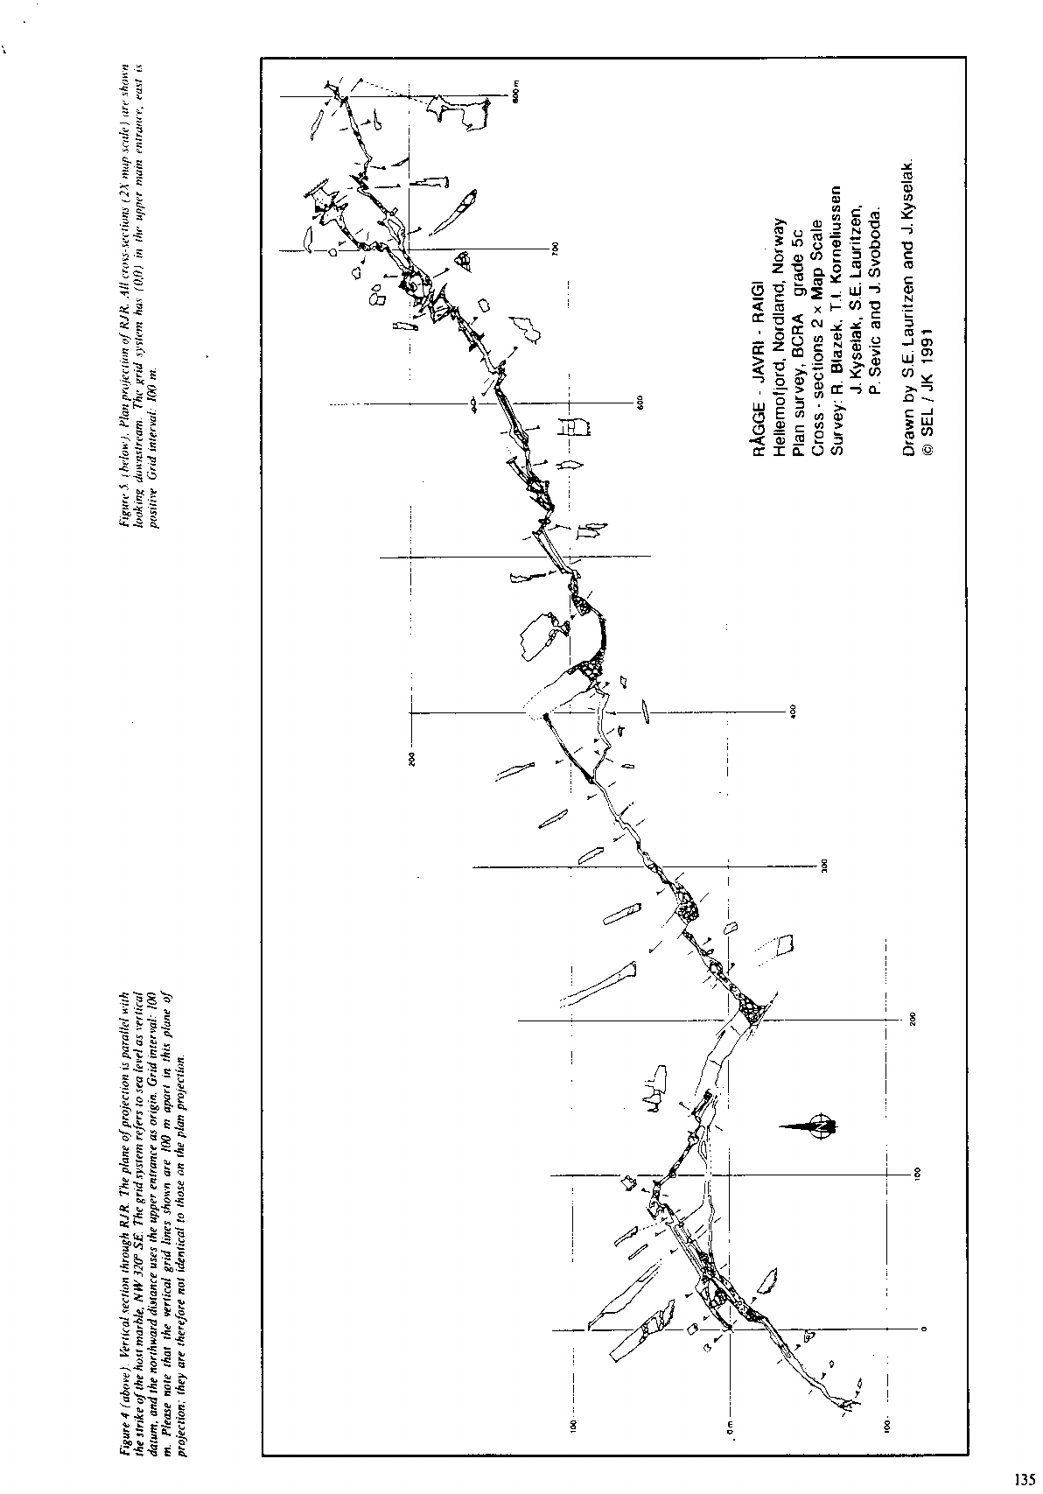
As expected, some of the avens seem to have horizontal connections at higher levels. Further penetration may require bolting and perhaps maypoling supported by camping at the site. We also consider the avens close to the top of Litlestupet as important targets for further attacks.
5) The NE wall of Litlestupet has a prominent recession above a ledge covered with rubble. To the extent we were able to observe the back wall of the recession (from the rope balcony), we could not, see any openings. However, most NE leads in the cave are quite low passages developed along subhorizontal fractures, unless they have been widened by vadose undercutting and collapse. Therefore, it is not unlikely that such a lead might have been overlooked.
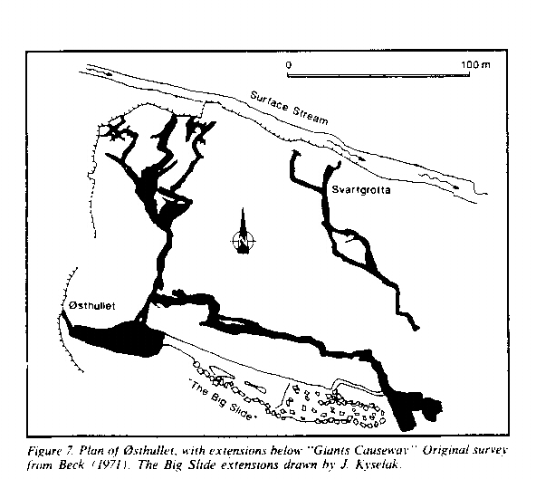
6) Between the Drinking Pool and Keystone Chamber, a high level route was surveyed on top of large blocks. The survey and exploration was terminated without reaching a definite end. The last survey station is marked "S22".
7) The top of Litlestupet and Galleriet correspond in altitude to the Raigejokka resurgence cave on the north side of the fiord. It is therefore likely that an old spring level might also be reached on the RJR side from the surface footpath along the 250 m a.s.l. contour. However, the steep cliffs and insignificant size of the known fjord entrance orifice suggest that this would be far from easy.
We would appreciate it if future visitors would take up these and maybe other leads and document their findings with the survey standards described above. We will then be able to link these extensions to our existing computer model of the cave.

Location of fixed survey stations

In the bottom of Clay Pot, above Wolf Walk, a good, fixed station is the rawlbolt rope belay (Station SI) for the last drop down to Wolf Walk.
Top of the 12 m pitch in Galleriet. When standing up to prepare the descent, the survey station (B09) is found at waist height on the left-hand (W) wall.
The last station at the top of Litlestupet (B19) is situated on the right hand (W) side of the passage, just before Galleriet opens out into the top of the pitch. Several survey stations further back in the passage are marked with circular soot marks (2-3 cm diameter).
The high level lead above Keystone Chamber is marked with station "S22". It is easily visible on the vertical wall just above the continuation of the passage.
Gour Passage drops into a rift chamber. At roof level, small leads may be found northeastward. The nearest station (S48) is located on the pointed corner only 1/2 m downstream of the lowest rock-mill pot, i.e. the "Gours" of the KCC survey (Heap 1970).
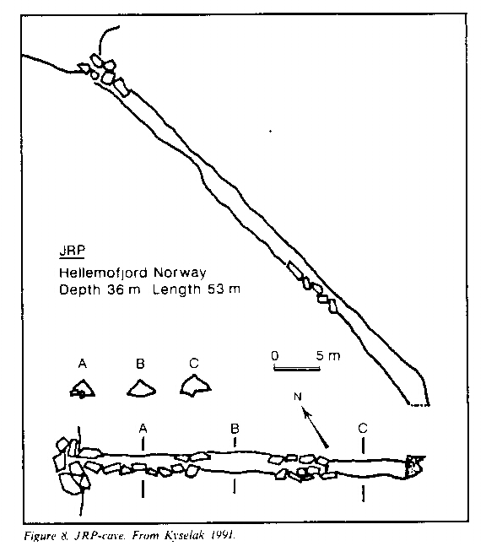

EXPLORATIONS ON THE NORRHERN PLATEAU

As mentioned, caves of the northern plateau, Noroldahkvarri, were previously explored and mapped by Heap (1969,1970) and by Beck (1971). We have inspected most of the known caves and provide modest additions.
Østhullet, extension of the Giants Causeway. A continuation of the main chamber, named the "Giants Causeway" by Beck (1971), was explored beyond the major boulder choke at the bottom of the chamber and the continuation found to run parallel with the main streamway passage (The Great Inclined Plane), and join into it at the terminus. The Big Slide extension adds nothing to the total depth of the system, but another 120 m to the length, now totalling some 900 m. The extension is shown in Figure 6.
The Lauknesfjell marble outcrop. As mentioned, the major marble outcrop, named the Lauknesfjell marble, supports some grikes and an underfit streamsink into the largest doline of the area. This small streamsink could not be penetrated. No other entrances could be seen within the doline, but a substantial snowpatch occupying the NE side halted complete inspection. On the distal ridge of the doline, several promising, choked shafts or widened grikes were located. Half a day was spent digging out one of these chokes. We penetrated some 2 m down; it still continues, but tools for moving large blocks are needed.
JRP-cave. Small cave entrances were found at the distal side of the marble outcrop, close to the fiord wall, but were choked with debris after a few meters. However, one of them could be explored for some 35 m at a relatively steep slope down to a boulder choke (Kyselak 1991). (See Figure 8).
Small canyon wall caves. The river draining from lake 735 into the Noroldahk-Raigi sink follows a minor marble band just downstream of the lake outlet. A series of small, shattered caves are located in the western canyon wall.

IMPACT OF VISITORS.

Due to the depth record and throughtrip possibilities, RJR has attracted numerous visitors from abroad during the past 20 years. Norwegian groups have also been active visitors, and we are of course aware that we, as scientists, also leave annoying signs of sampling and excavation behind us. The area has also become much more accessible, recently manifested by the hydroelectric power lines crossing the fiord just above the Noroldahk-Raigi waterfall sink. Wilderness, apparently, is the loosing part.
The impact of travel is quite visible in RJR, where distinct footpaths may be seen in several places. Occasionally, limestone is abraded and often smeared with clay. Rusty rawlbolts may be seen in numbers above and around the major drops. Such worn belays and handholds would contribute to making the cave less safe with time. We found the lower route down to the Fiord Cave by tracing pieces of toilet paper and topofil string, hence the name "Bogroll Squeeze". Very few of these travel marks could be seen during a previous visit by one of us (SEL) in 1982, although Holbye (1977) reported that old telephone wire could be found inside the cave. We have finally removed this historically necessary wire of agony from the outside dump and brought it down by helicopter with our own garbage. Judging from the state of other caves in the area, RJR seem to have attracted almost all caving activity in the region. In our judgement, the Noroldahk caves were practically untouched in comparison with RJR. It is therefore evident, that the perhaps most famous of all Norwegian caves is in the process of sacrificing pristinity for the temporary benefit of its virgin neighbors,
According to the value classification and management categories we have applied to Norwegian karst sites (Lauritzen 1988, 1991), RJR is a typical "sporting cave" and should also be devoted to this kind of use in the future. It is, however, an interesting site where we may test a cave's travelling capacity, i.e. how many visitors such a system may take before impact becomes visible. We would therefore appreciate receiving more accurate estimates of the total number of individual through-trips that have been made. Moreover, a few sensitive features are of scientific interest in the cave: insect remains and sediment banks. Both are rare and very vulnerable to trampling, and we hope they will remain as references for the future. For instance, we have just in time, "saved" a section of the Clay Pot deposit paleomagnetic measurement. This site is a part of the much travelled Upper Traverse route down to Storstupet.
Another unique value of RJR is the strong thermal wind through the entrances. This phenomenon is unlikely to be affected much by future use of RJR, provided that no changes are made to entrances or constrictions inside the cave.

ACKNOWLEDGEMENTS

Field work was financially supported by the Norwegian Science Foundation (NAVF). the Norwegian Oil Directorate, the Directorate of Nature Management and by Fridtjof Nansen and affiliated funds for the advancement of Science and the Humanities. Expedition members were, in addition to the authors: Petr Sevcik, Jitka Sevcikova, Radek Blazek, Jan Svoboda and Tor Inge Komeliussen. We also enjoyed support from members of the Czech "Trias" caving club who joined us for a shorter time. Our efficient sampling and surveying programme would never have been possible without excellent rigging done by lain Schrøder and his Norwegian "adventure travel" group of no less than 18 persons! Survey parties were: Upstream parts and Ice Climb to Fiord Cave (P. Sevcik and R. Blazek). Drinking Pool - Ice Climb and Clay Pot - Upper Traverse (S.E. Lauritzen and T.I. Korneliussen). Remaining parts were done by J. Kysciak and J. Svoboda. The expedition was organized after the "Kon-Tiki Raft" model: an international team working together within a lateral rather than pyramidal organization All members contributed equally to the present result. This has proven successful before (i.e. Lauritzen et al 1986). Although food preparation was a circulating duty, we all became faint amateurs when encountered to the delicious, spicy meals of Jitka Seveikova. The people in Musken provided tolerance and helpfulness, and the council of Tysfjord municipality permitted the use of helicopter on the state-owned land. Needless to say, we are also indebted to the original explorers for their surveys and the ideas they have initiated. We owe them all our sincere thanks. This is contribution No. 24 of the Karst research Project in Norway.

REFERENCES.

Andersen, B.G. 1975: Glacial Geology of Northern Nordland, Norway. Norges Geol. Unders. 320 74 pp.
Andersen, B.G., Bøen, F., Nydal, R., Rassmussen, A. and Vallevik, P.N. 1981: Radiocarbon dates of marginal moraines in Nordland, North Norway. Geografiska Annaler 63A (3-4) pp. 155-60.
Beck, H. 1971.. Craven Pothole Club Expedition to Arctic Norway, Craven Pothole Club Journal 4(5) pp. 240-249.
Corbel J. 1957: Les Karsts du Nord-ouest de I'Europc et de queiques regions dc comparaison. Inst. Etud. Rhodann. Memoires 12. 541 pp.
Courbon, P. 1972: Atlas des Grands Gouffres du Monde. Provence 54 pp + plates. Courbon. P. and Chabert. C. 1986: Atlas des Grandes Cavites Mondiales. Union Internationale de Speleologie and Federation Francaise de Spelcologie. 255 pp. Ellis. B. 1976: Surveying Caves. British Cave Research Association, Bridgewater.

Somerset. 88 pp.
Foslie S. 1942: Hellemobotn og Linnavarre. Norges geol. Unders. 150. 119 pp.
Gjessing, J. 1967: Norway's Paleic Surface. Norsk Geogr. Tidsskr. 21, pp. 69-132.
Heap, D. 1969: Report of the British Speleological Expedition to Arctic Norway, 1969. including the work of 1968. Hulme Schools Expedition. Kendal Caving Club 1969. 37 pp.
Heap, D. 1970: William Hulme's Grammar School's Expedition to Arctic Nordland 1970. Manchester 1970. 21 pp.
Holbye, U. 1977: Rapport fra turen til Råggejavre-Raige 1976. Norsk Grotteblad 1 (1) pp. 1-58.
Horn, G. 1937: Uber einige Karsthohlen in Norwegen. Mittl. Hohlen u. Karstforschung, pp. 1-15
Kyselak. J. 1991: Scandinavien '91. Speleoforum 1991 pp. 24-28.
Lauritzen, S.E. 1988: Karst Environment Protection in Norway. Proceedings of IA H 21st. Congress: Karst Hydrologi. and Karst Environment Protection, 10-15 Oct. 1988 Guilin, China. pp. 109-114.
Lauritzen. S.E. 1990: Tertiary caves in Norway a matter of relief and size. Cave Science 17 @ 1), pp 31-37.
Lauritzen. S.E. 1991: Karst Resources and Their Conservation in Norway. Norsk geografisk Tidsskrift In press.
Lauritzen. S.E., Abbott, J., Arnesen, R., Crossley, G., Grepperud, D., lye, A. and Johnsen, S. 1985: Morphology and hydraulics of an active phreatic conduit- Cave Science 12, pp. 139-146.

Stein-Erik Lauritzen.
Department of Geology,
sect. B. Bergen University
Allegaten 41.
5000 Bergen. Norway

Jiri Kyselak.
Druztevni 991,
67401 Trebic,
Czechoslovakia.

Reidar Løvlie,
Department of Solid Earth Physics,
Allegaten 41,
5007 Bergen, Norway.

Appendix: Nomenclature of RJR.

Beyond any doubt, the original explorers possess the sovereign right to name the features which they document on their surveys. On the other hand, later explorers (i.e. Holbye 1977) have advocated the need for translating English names into the language of the host country. This attitude was already customized by Heap (1969), who adapted the Lappish naming of the cave itself. The lake is named Rågge-Javri, meaning "the lake in the (shallow) pit". Raigi means cave, hence the cave's name would read something like "Pit-Tarn-Cave". This is not a unique name, as there are several tens of "Rågge-Javri" tams and lakes in northern Norway, many of them with caves connected to them. But RJR is indeed the Rågge-Javri cave, and of course, nobody would ever dare to challenge this name elsewhere!

In the following, we present our attempts to make appropriate translations of the original KCC English names and vice versa, with one exception: "The Hall of The Mountain King". This name, "Dovregubbens Hall" in Norwegian is taken from the Peer Gynt suite by the Norwegian composer Edvard Grieg, and has unfortunately been thoroughly 'abused ever since by the tourist and film industries. Second. "Dovre" refers to a mountain massif in South Norway. Third, the term refers to "Trolls", which are not inherent in Lappish tradition: we may rather encounter the "Stallo" (devil) in names like Stallo-Råggi (Devil's pit). For all these reasons. "Hall of the Mountain King" does not sound too good to most contemporary Norwegian cavers. Holbye (1977) expressed similar views and suggested the understatement: Litlestupet (little Pitch') for the site. This has been in use ever since, and we take the liberty of adapting the name as permanent. Other names like "Keystone Chamber" sounds good to us, and we have decided to entirely use the English form. Being aware that naming is a sensitive issue, subject to taste and therefore endless debate, we nevertheless hope that our suggestions in Table II and Figure 9 may be used as a consistent nomenclature for the future.
English name | Norwegian Standard | Lappish form
Main Entrance | Hovedinngangen | Canadag
Upper Streamway | Øvre Bekkegang
Big Rift | Store Skrå | StuorGållo
Top Traverse | Øvre Travers
The French Opening | Fransk Åpning | -
.Main Slide | Hovedsklia | -
Clay Pot | Leiregryta | -
Wolf Walk | Ulvegangen | -
Cascades | Strykene
Winch Balcony | Vinsjbalkongen | -
Big Pitch | Storstupet | Stuorgahcdag
Great Avens (1-7) | Storpipene (1-7) | Riephena
Trundle Gallery | Galleriet
Razor Passage | Knivgangen | Salsag
Hall of M. King | Litlestupet | Hagno
Balcony | Balkongen | Latnja
Drinking Pool | Drikkefonten
Keystone Chamber | Keystone Chamber
High Level Lead | S22
Gour passage | Grytegangen
Silt Drop | Siltstupet
Ice Hall | Ishallen
Ice Climb | Isblokka
Mistral Passage | Mistralgangen
Mistral Shaft | Mistralsjakta
Bogroll Squeeze | Markeringsklemma
Fiord Entrance | Øvre Utgang | Ålgus
Fiord Cave | Fjordgrotta | Vuoleb RJR

